SUPERVISION
Date / time: 27/11/2025

Main issues discussed
1. You don’t need to worry too much about the word limit; if there is a good justification and the writing is strong, a longer length is acceptable.
2. The requirements and challenges of the Presentation (CW2).
3. Presentation arrangements with the second supervisor (Taylor Ring).
4. Use of Appendices and Online Resources

Work shown
- Draft for energy consumption measurement.
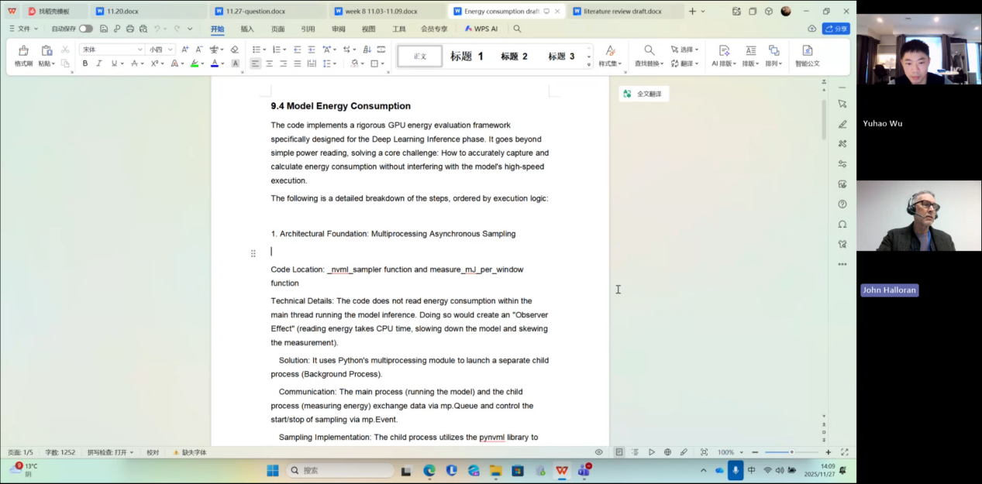
- Github code
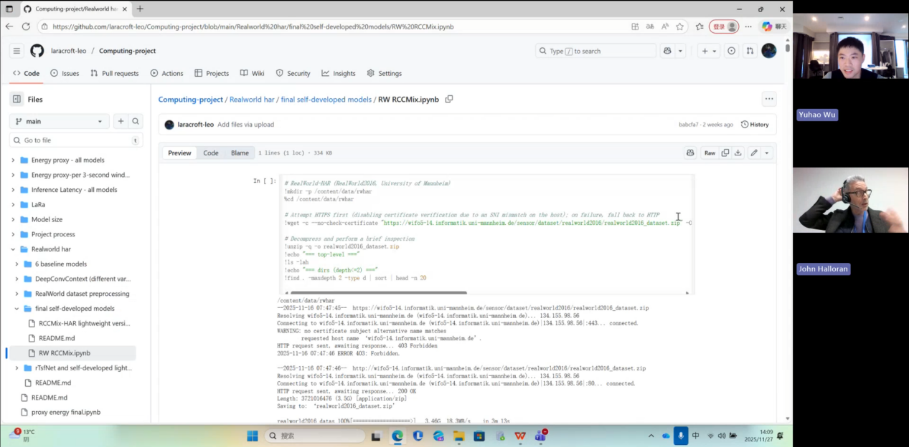

- Literature review
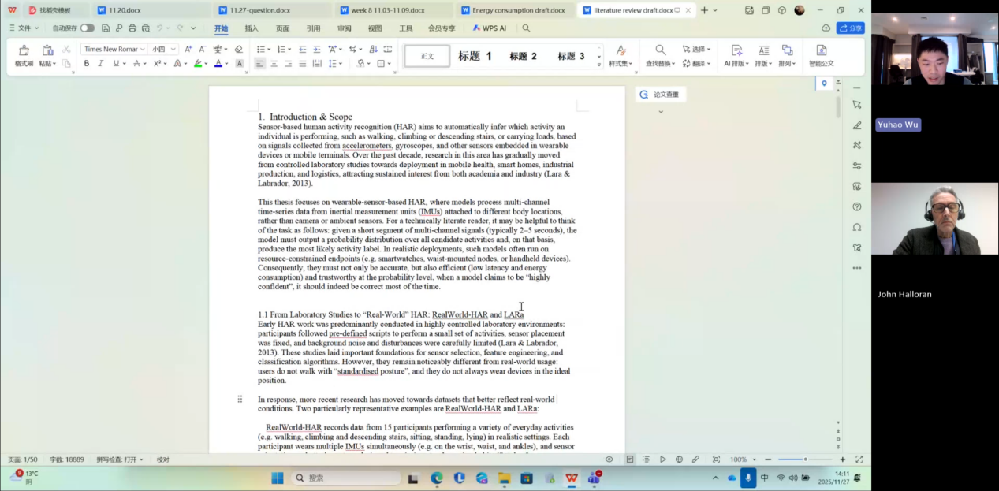
Questions asked; how questions were answered
My dissertation is currently 50,000 words long; is that too much?

Answer
50,000 words is indeed “a lot”, but if you truly did a lot of work, a large word count is natural. The key question is why it has become so long. I need to take a look before I can give you feedback.

Email
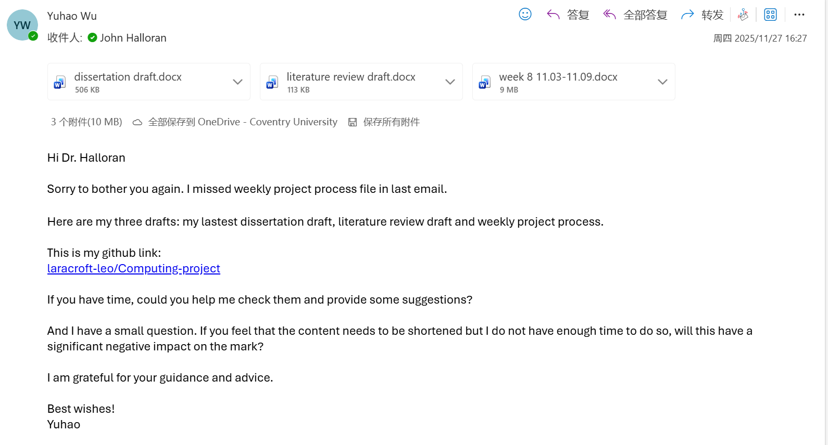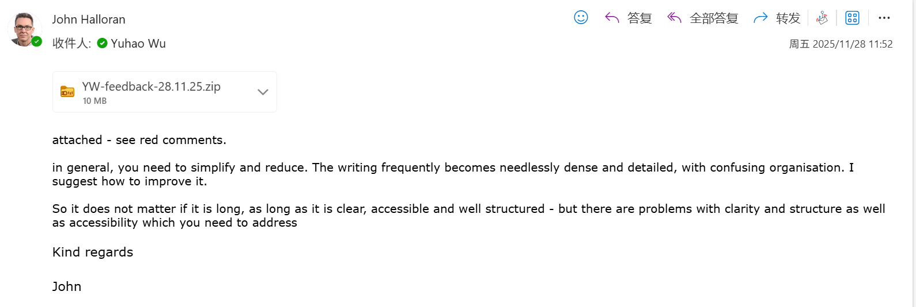

Computing Project
WORK DONE
- Literature review
- Weekly project process

Issues and challenges
1. There are many problems with the literature review, such as the heading hierarchy and overall organisation.
2. The project process needs to be simplified.
3. The dissertation title is confusing, and some parts are not clear enough.

Actions for next week
Finish the dissertation and prepare the presentation.

Evidence
Part 1
https://livecoventryac-my.sharepoint.com/:v:/g/personal/wuy176_uni_coventry_ac_uk/IQC5GkxwLGsORJNE-1sB_yfDAYEm9NSPVNLX4-IrbiDJyik?nav=eyJyZWZlcnJhbEluZm8iOnsicmVmZXJyYWxBcHAiOiJTdHJlYW1XZWJBcHAiLCJyZWZlcnJhbFZpZXciOiJTaGFyZURpYWxvZy1MaW5rIiwicmVmZXJyYWxBcHBQbGF0Zm9ybSI6IldlYiIsInJlZmVycmFsTW9kZSI6InZpZXcifX0%3D&e=V4Cnqg

Part 2
https://livecoventryac-my.sharepoint.com/:v:/g/personal/wuy176_uni_coventry_ac_uk/IQD6XBhccrLET6GeM-yy0YCQAdF8HyLNOxYl_rH7FBSreuA?nav=eyJyZWZlcnJhbEluZm8iOnsicmVmZXJyYWxBcHAiOiJTdHJlYW1XZWJBcHAiLCJyZWZlcnJhbFZpZXciOiJTaGFyZURpYWxvZy1MaW5rIiwicmVmZXJyYWxBcHBQbGF0Zm9ybSI6IldlYiIsInJlZmVycmFsTW9kZSI6InZpZXcifX0%3D&e=UQDQqS

